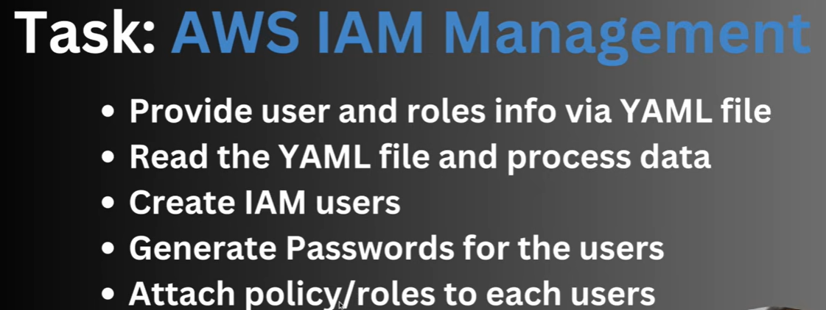

Yaml file
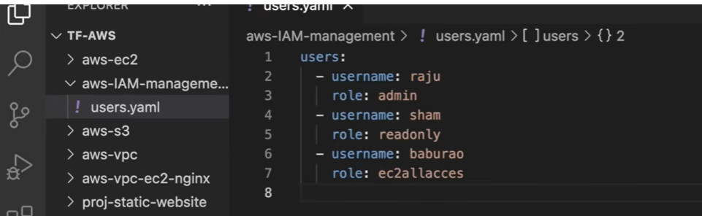

Main.tf
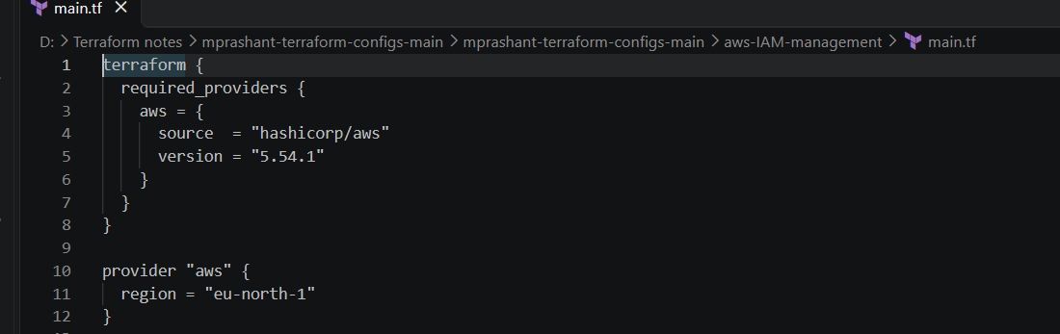
Reading data
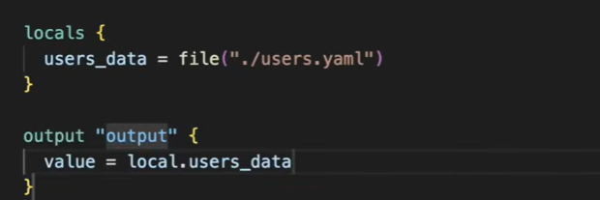
Output
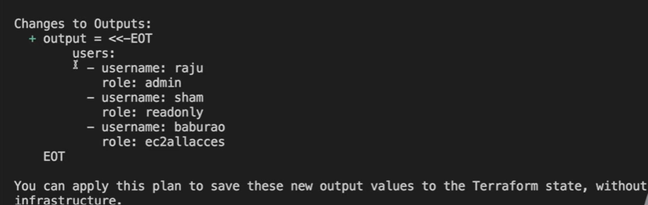
We need data in different format
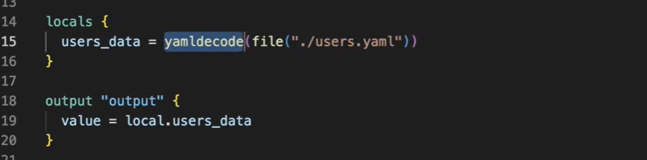
Now output
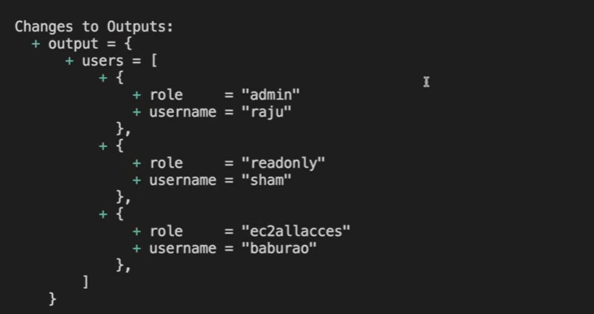
Now data is coming in format of list.
Output = and user = is coming but we don`t need user = but we need data which inside user.
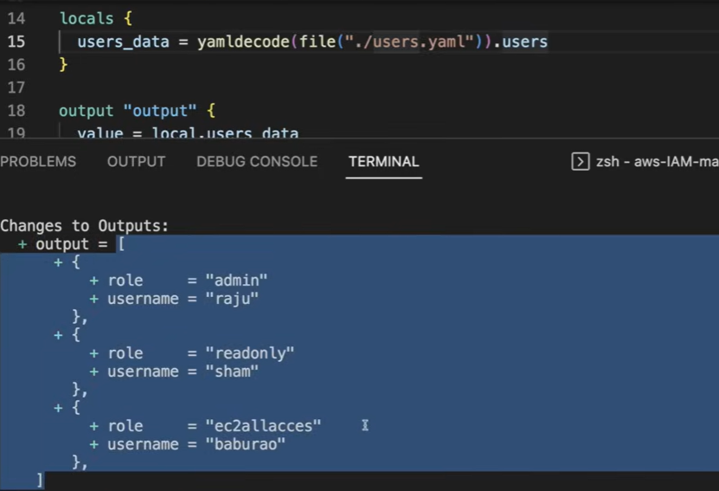
Now it`s coming in proper format. We are getting three objects.

If I need only user data
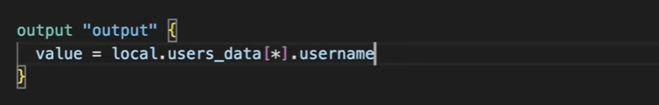
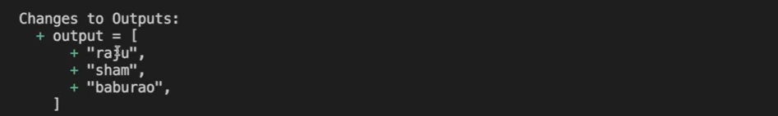

Now we have to create the account for all the users present in user data
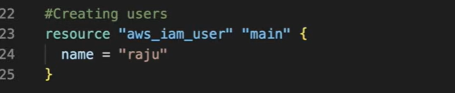
So instead of giving static name, we can take the name from list
Set don`t allow duplicate data.
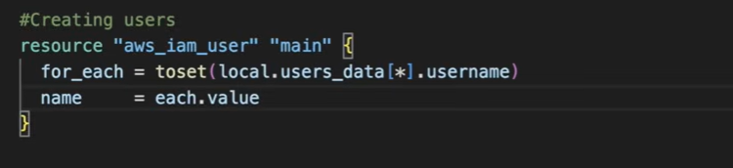
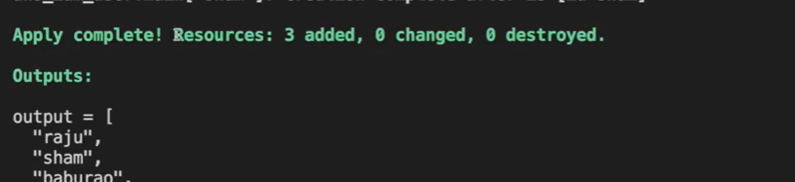
We can check the resource now
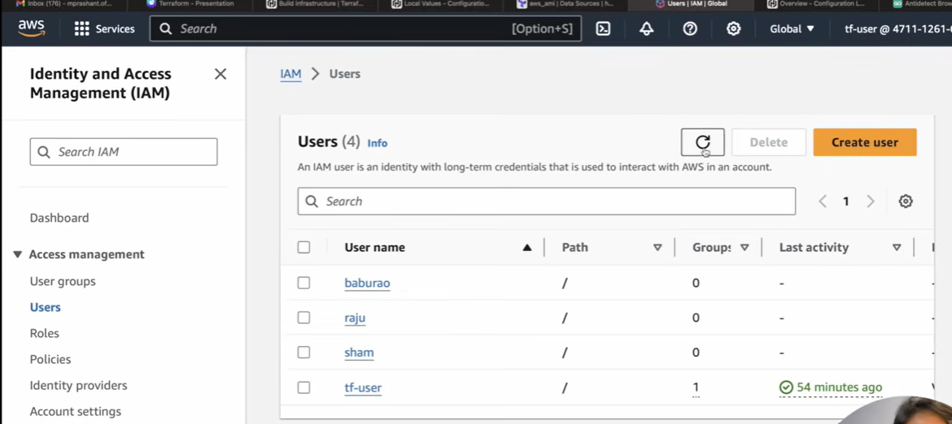
Now we have to set login credentials
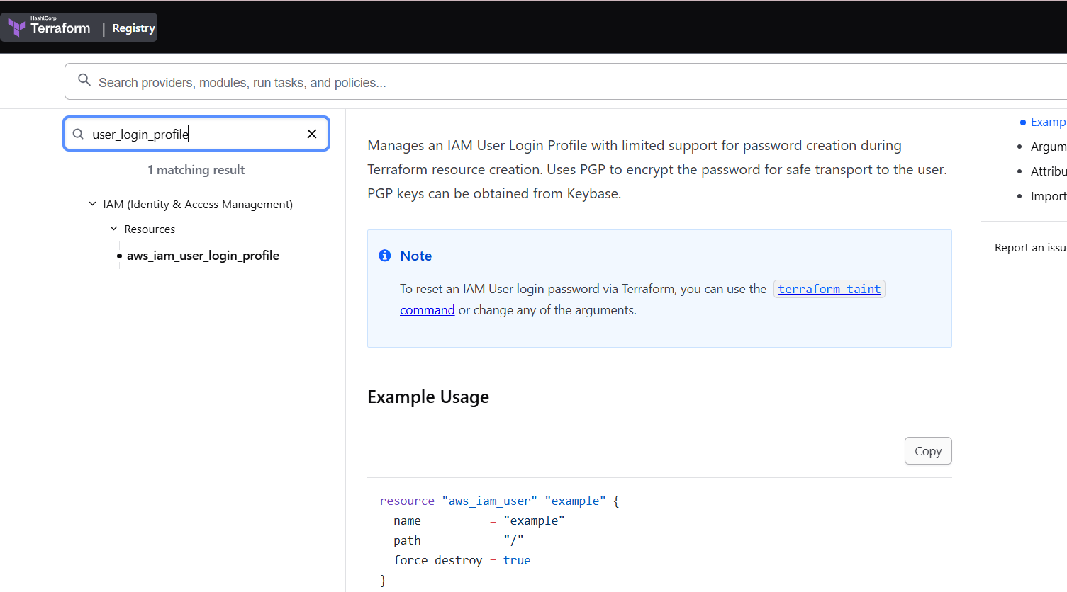

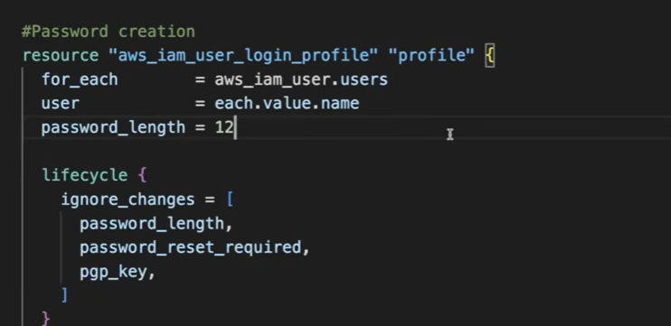
After creating these resources, we can get password in tf.state for all user.
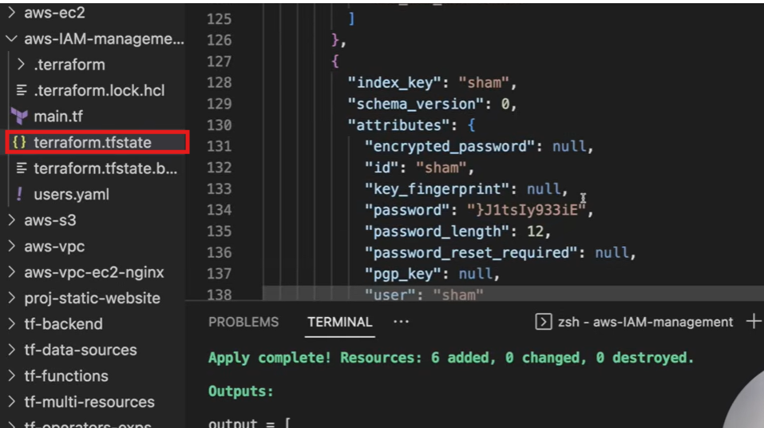
Now we can login with new password


For tf user admin access permission is there but there is no permission for other user
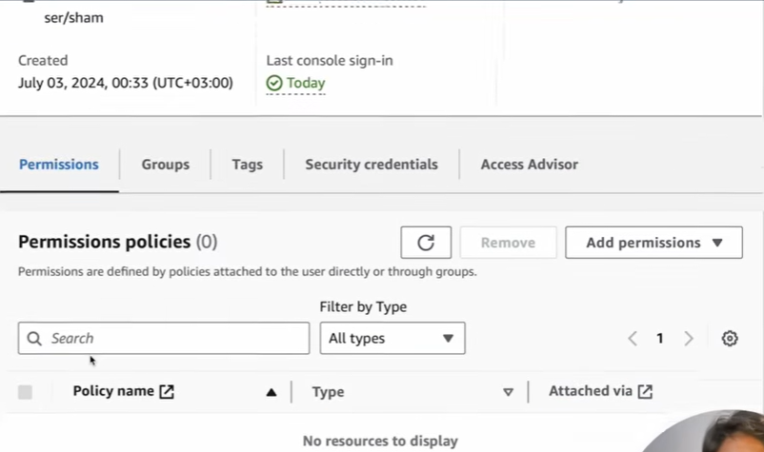
We have to create user permission now.

AWS has already some predefined policies
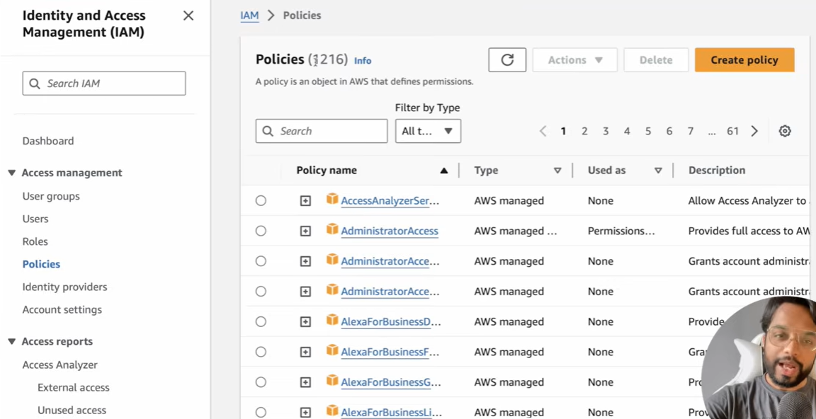

Policies for EC2
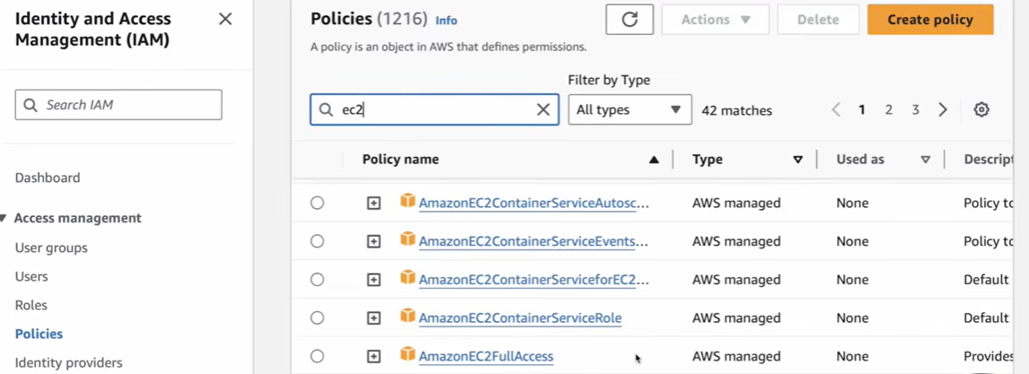

Policies for SC3
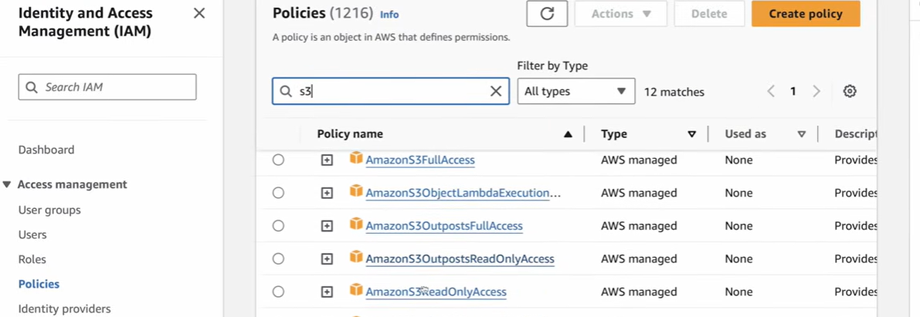
We can create our own policies
At the place of role, we will give proper policies name in YAML file
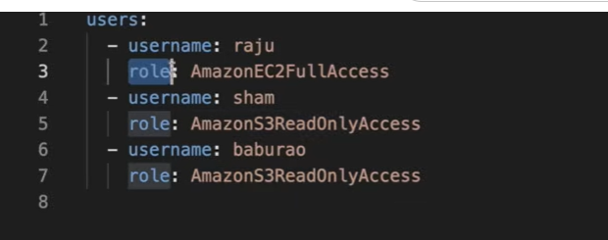
For giving multiple roles, we can write it in the form of list.
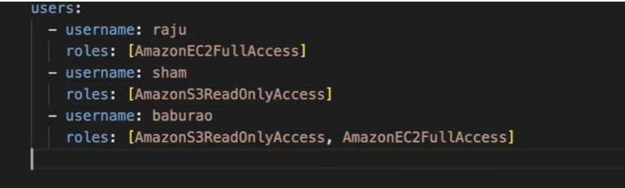

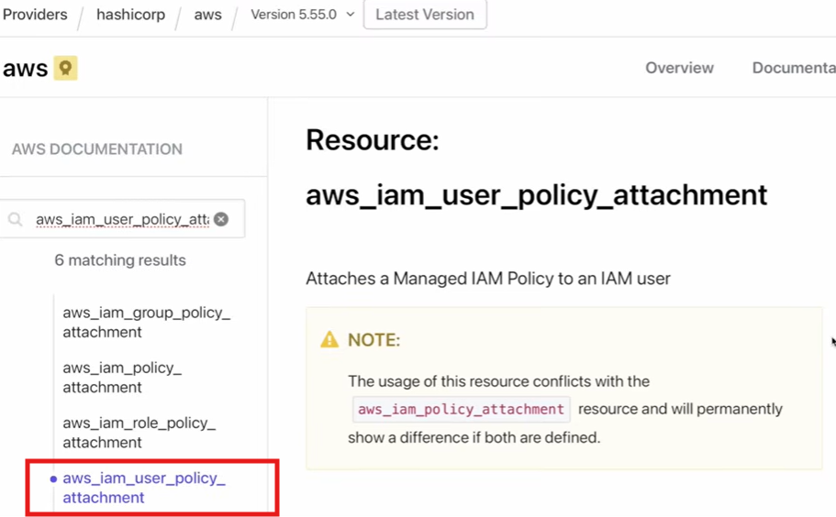
The two parameter is most important
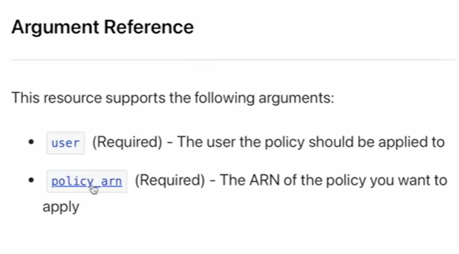
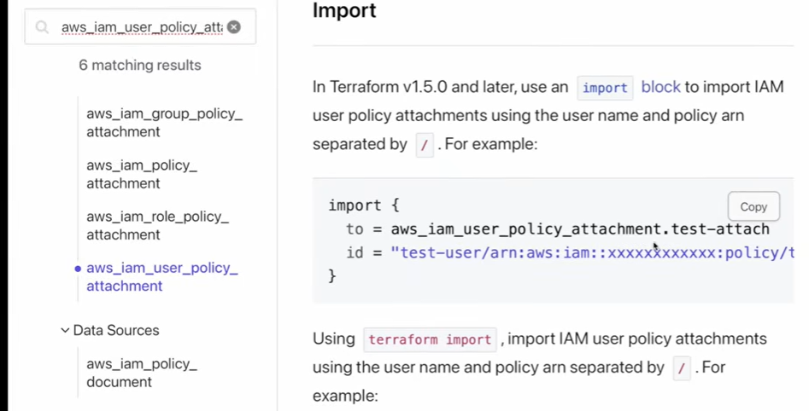

Our present structure is like
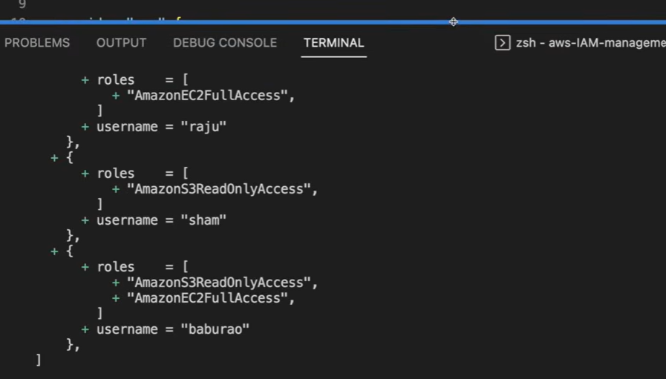
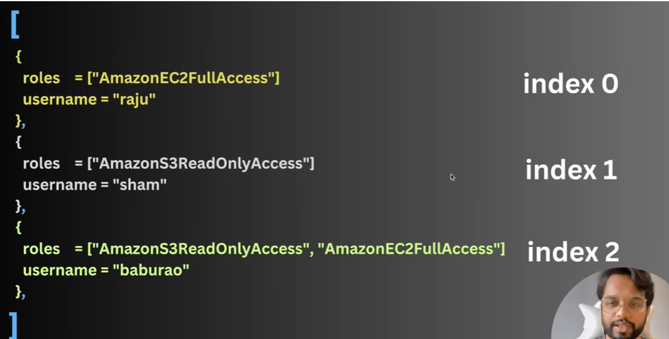
Here baburao has 2 roles but I want it in below given format
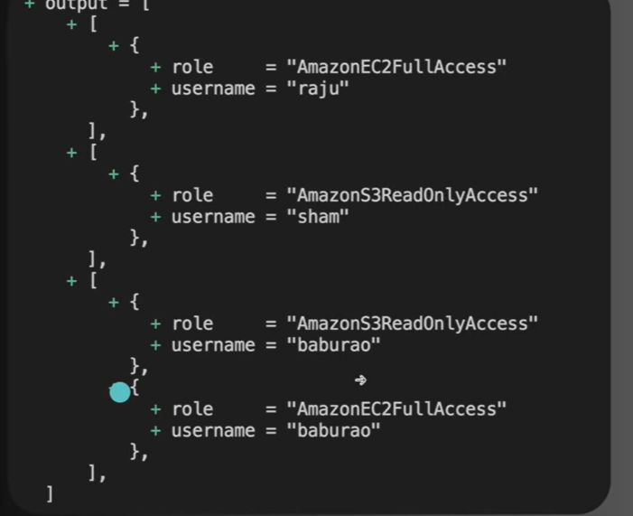

We have changed the list and one list is under another list
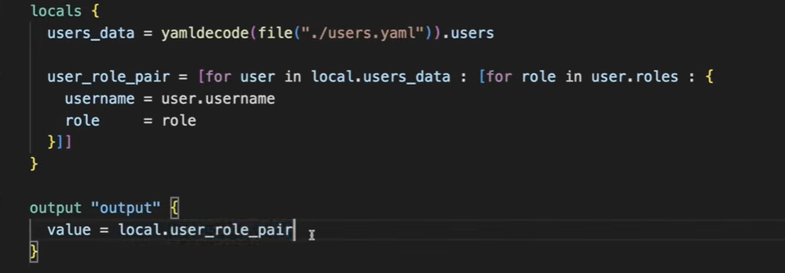
Output
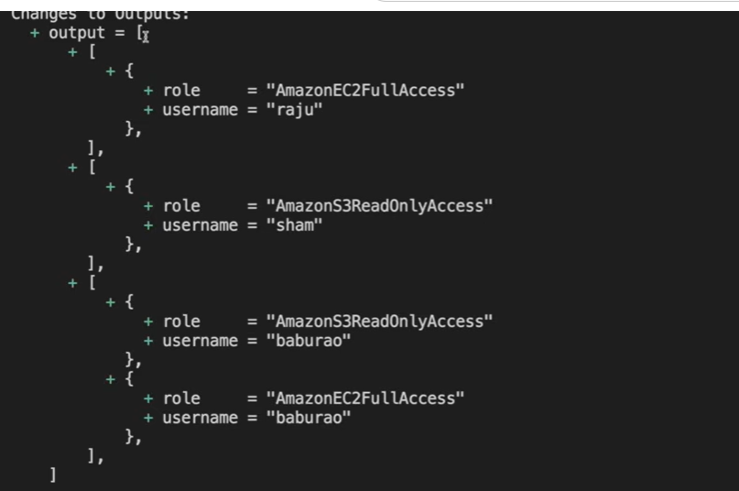

Code can be further simplified by using flatten function
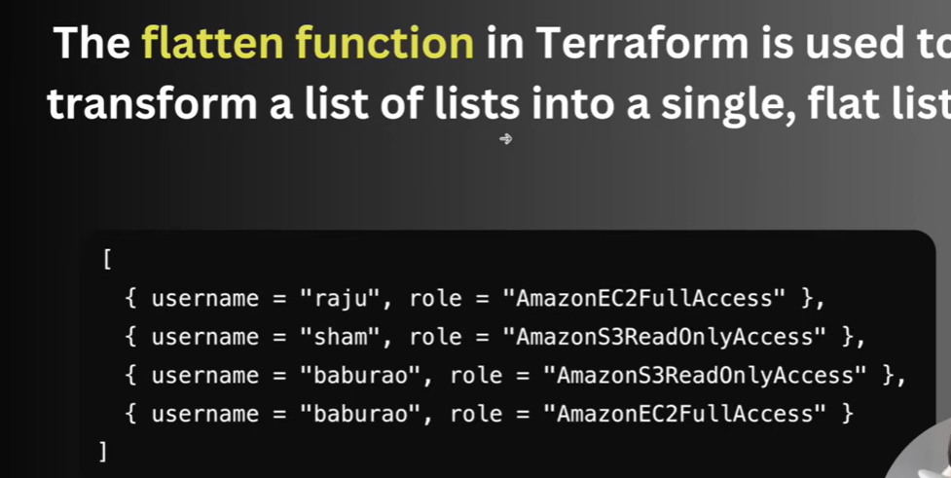
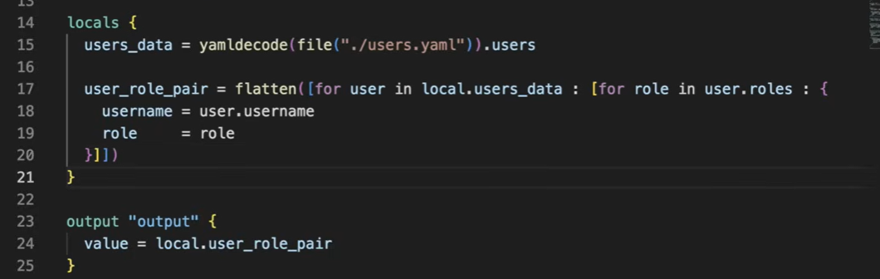
Output
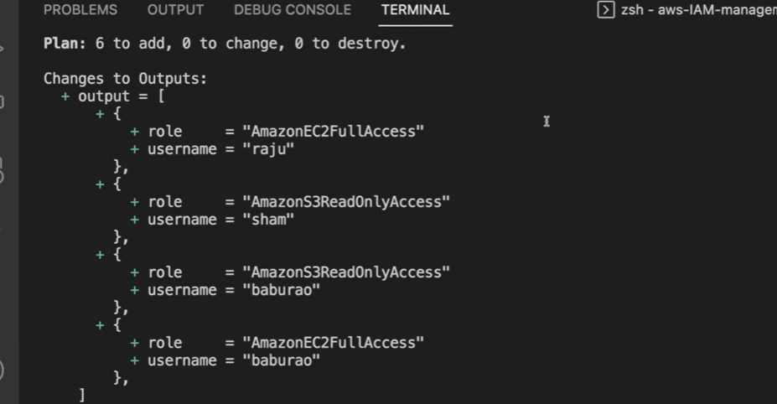

Attaching policies
Here baburao is repeated so can write username directly, so we have to create a key pair bcz key beome unique.
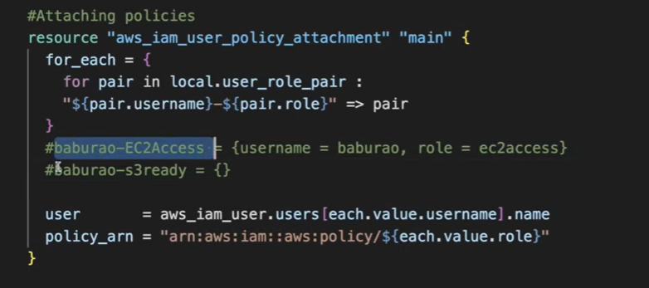
Now policies will be
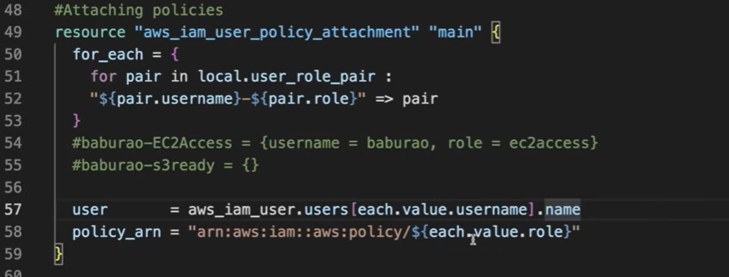

Now baburao has two attached policies
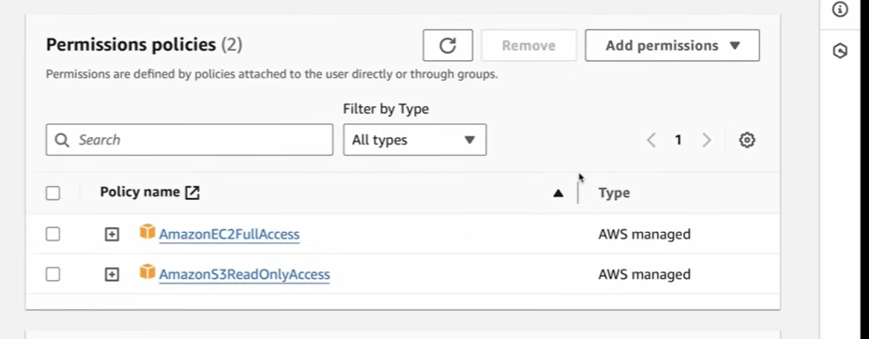

Raju and sham is one-one policies
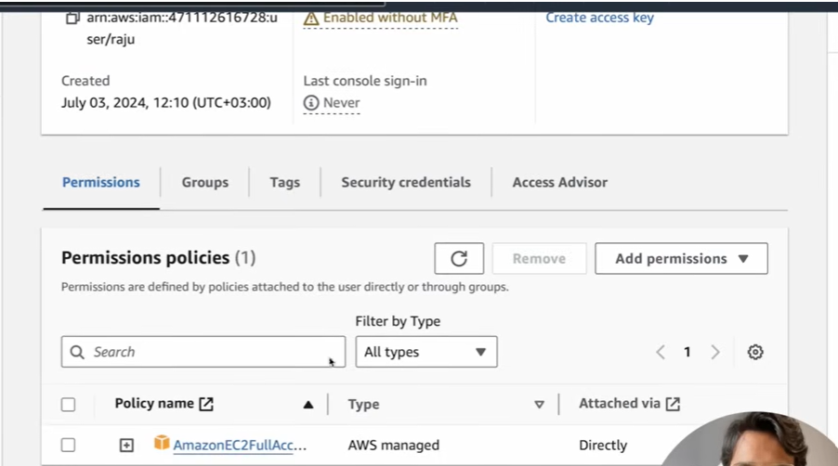
We can log in and check now the access now.

